Design of Social Robot

Project Progress Documentation

**Team 4**

Table of Contents

Objective 3

Steps 3

Lab Session 1 6

Lab Session Attendance Log (11/2/2019) 9

Lab Session 2 10

Lab Session Attendance Log (11/9/2019) 12

Lab Session 3 13

Lab Session Attendance Log (11/16/2019) 16

Step by Step Build Procedure 17

# Objective

To build a fully functional Social Robot Head based on Artificial Intelligence controlled by servos, programmed by PSOC Creator.

# Steps

1. First, we started looking into the blue prints of the design. From this we got higher level overview of what parts are needed and where each part goes.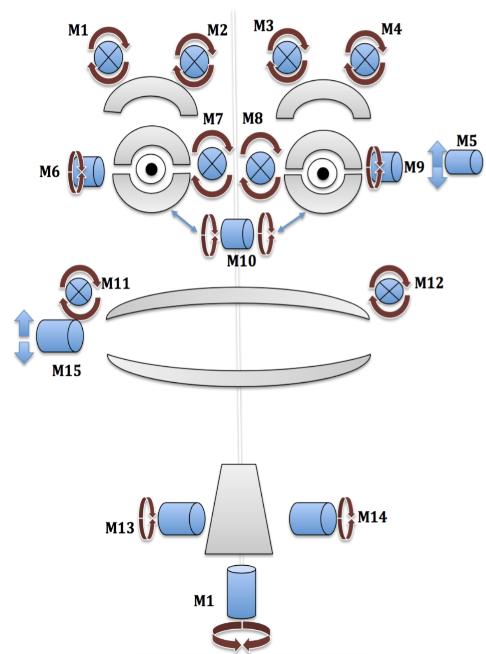
2. We started with ordering the various mechanical parts needed for the build like the servos, joints, bearings, support rods, ...
3. We got our environments setup for PSoC programming and went through the tutorials posted.
4. Parallelly we started with 3D printing the robot head parts such jaws, eye balls, eyebrows, neck and other support structures which could be controlled with servos.
5. The following settings were used for 3D printing
   * Material: PLA
   * Layer Height: 0.25mm
   * Top/Bottom Thickness: 0.8mm
   * Infill density: 40%
   * Infill Pattern: Lines
   * Print Temperature: 215°C
   * Bed Temperature: 70°C
   * Support Z distance: 0.27mm
   * Support Overhang Angle: 50°
   * Support Density: 15%
   * Support Placement: Everywhere
   * Print Speed: 60mm/s
6. We visualized the models in our local systems in **Ultimaker Cura**, the software used for setting up the models for 3D printing on lab printers.

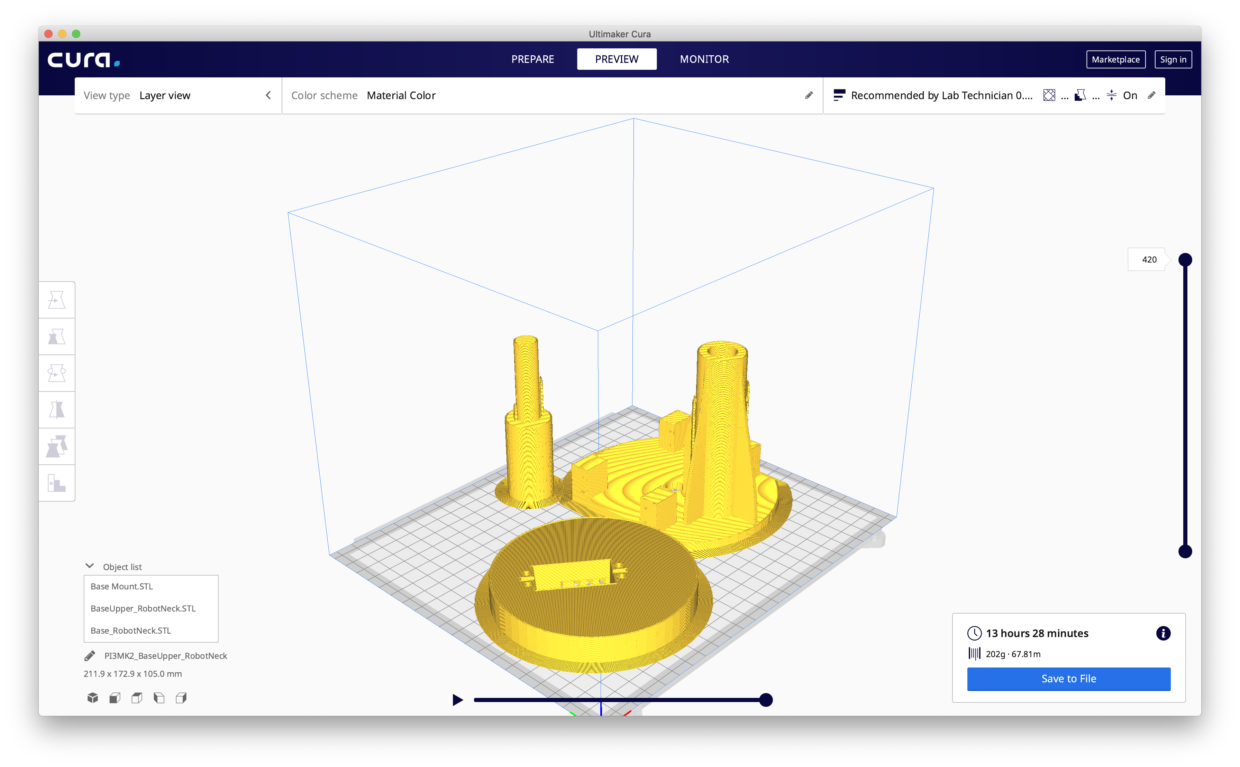

1. We estimated the time taken for each 3D print session and took turns accordingly to get all parts printed on time.

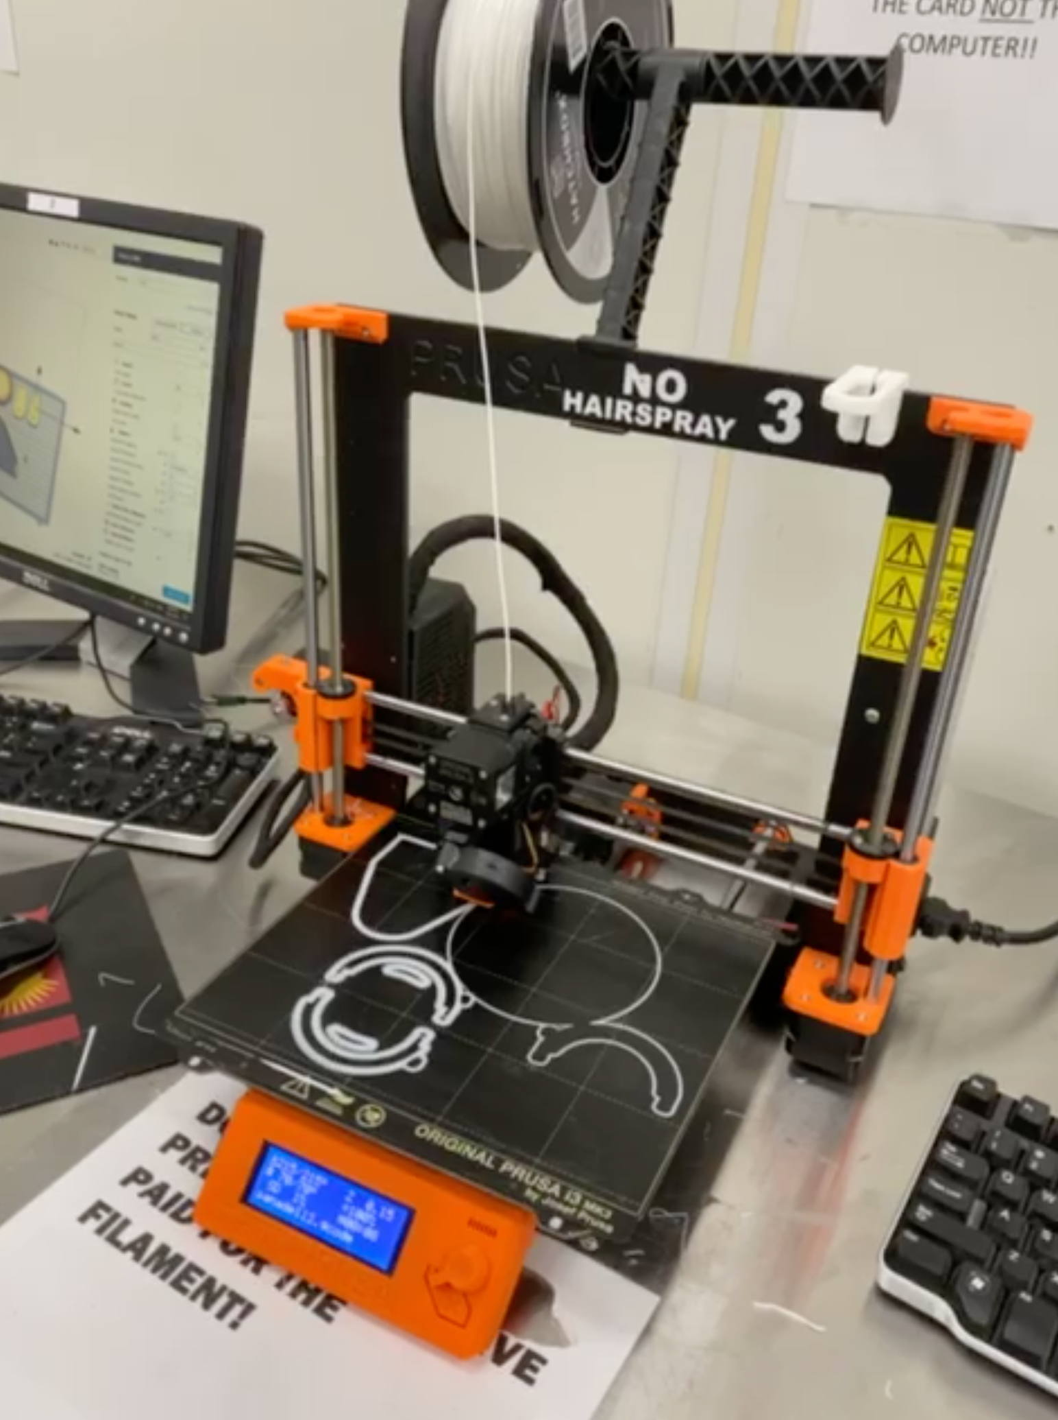

1. We used **Prusa i3 MK2** printer for printing all our robot parts.­­­­­

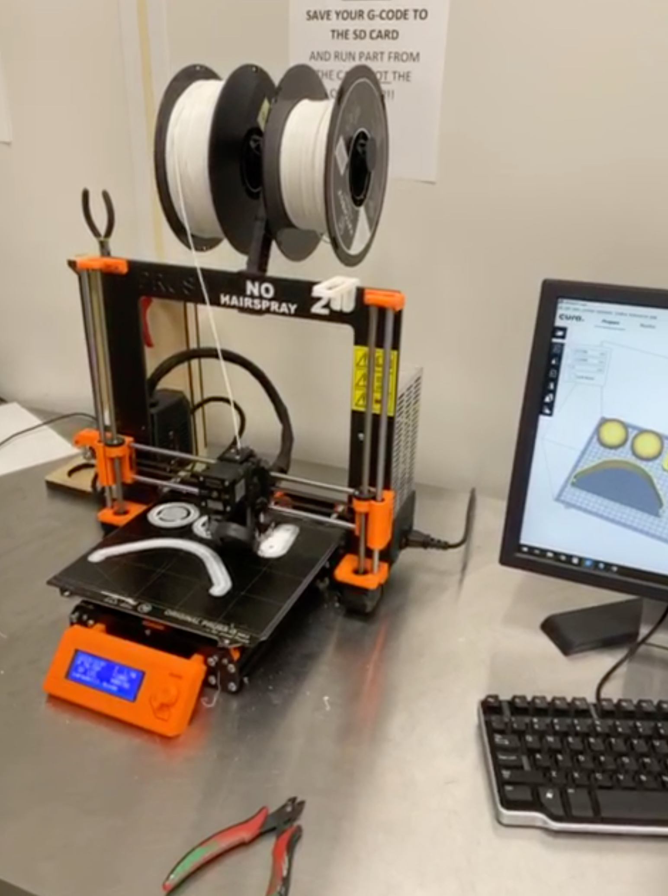

1. Considering the large team size, we used Trello, a project management software to track our team progress.

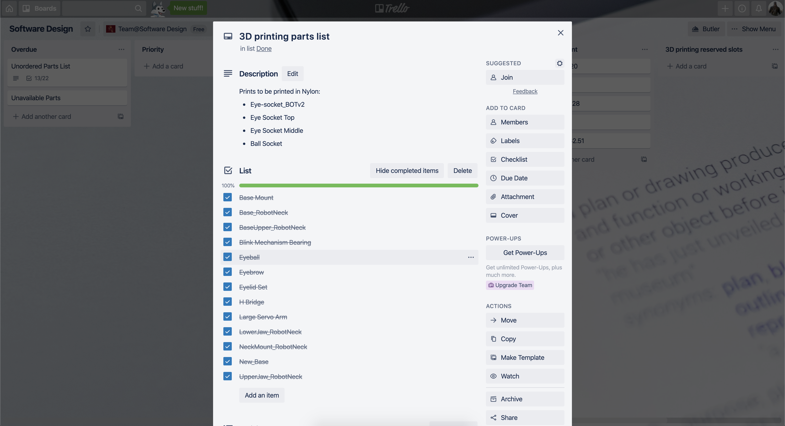

# Lab Session 1

1. After 3D printing the parts and having all other parts shipped, we started assembling these.
2. First, we started with sanding and cleaning the support material off the 3D printed parts.
3. We started with the central portion of the head which has the most number of servos. It is shown in the figure below.

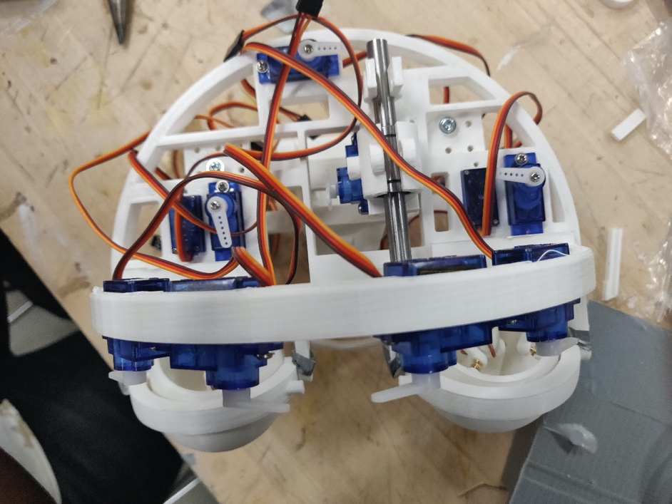

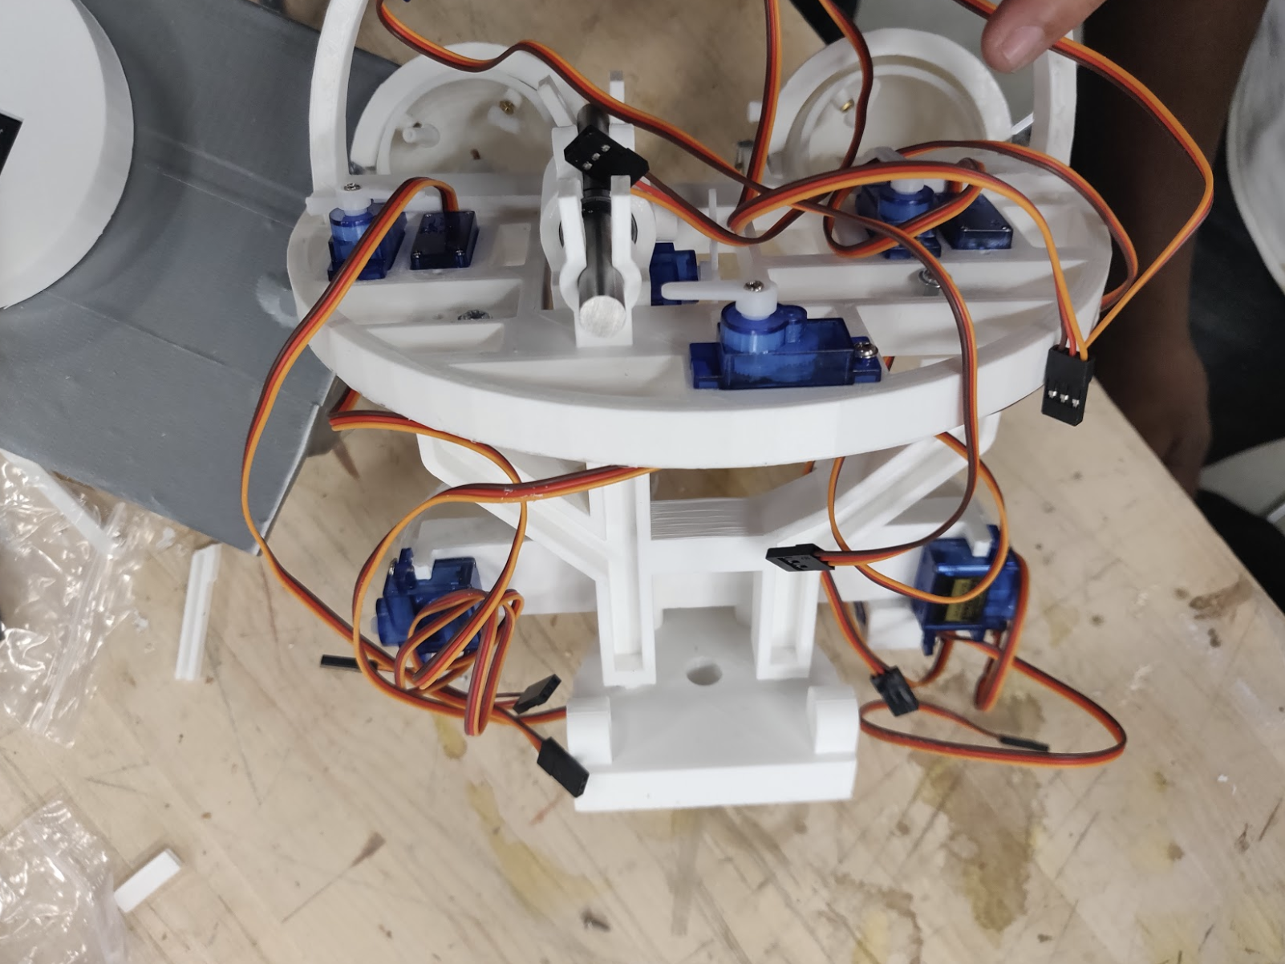

1. We then parallelized the work with two people working of servo fitment while others worked on cleaning off support material, getting rods fixed, getting holes drilled for eye ball fixture and getting the servo push rods cut to appropriate structure and dimensions.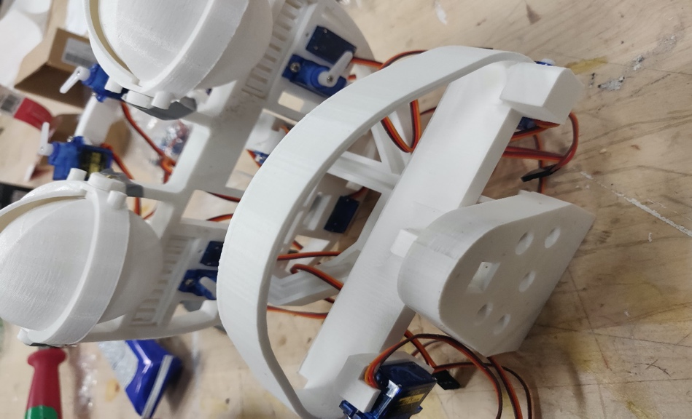
2. Then we fitted the top of the head with some servos for the eyebrows.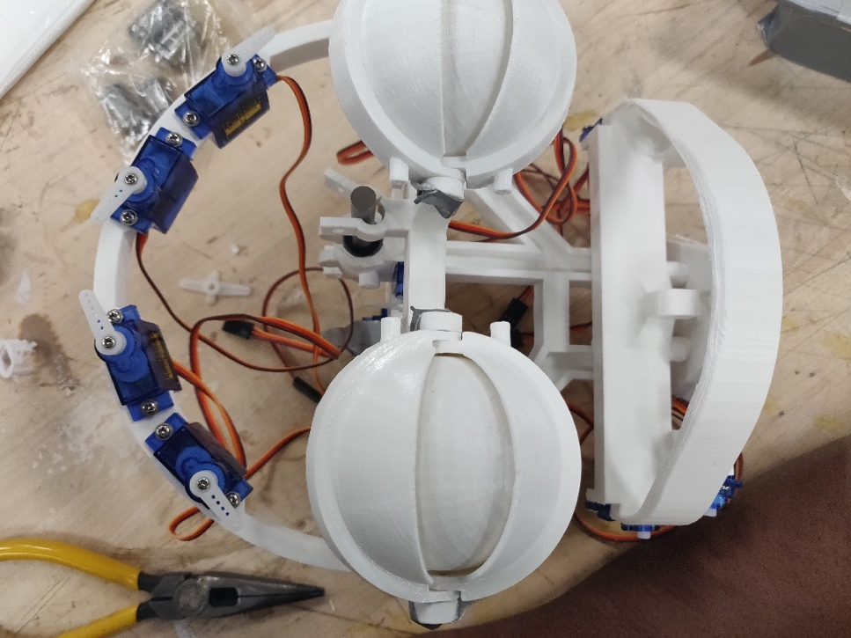
3. Then we assembled the eyes and connected the sockets, rods needed for the servos to control.
4. Next we connected the jaws and the corresponding servos to it. The lower jaw dimensions were a bit off and hence we sanded off the holding material and glued the servo gear to the jaw for better stability.
5. We also built a base on which the robot would be fixed.

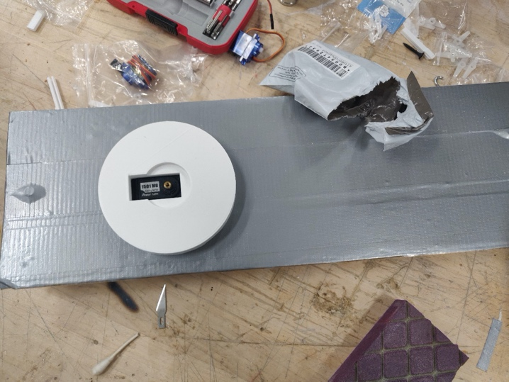

1. After this we had a bunch of parts which needed assembly.
2. While part of the team started the assembly work, the other part of the team started exploring PSoC programming and got the basic LED blinking program working onboard.
3. The head was assembled and then we used the universal joint to connect the neck of the robot to the head and it provided the 360 degree movement to the robot’s head.
4. We also fitted the robot with large servos which held the head upright and enabled it to turn left or right.
5. We even fixed the base mount servo needed for rotating the base.
6. After the assembly the robot looked like this

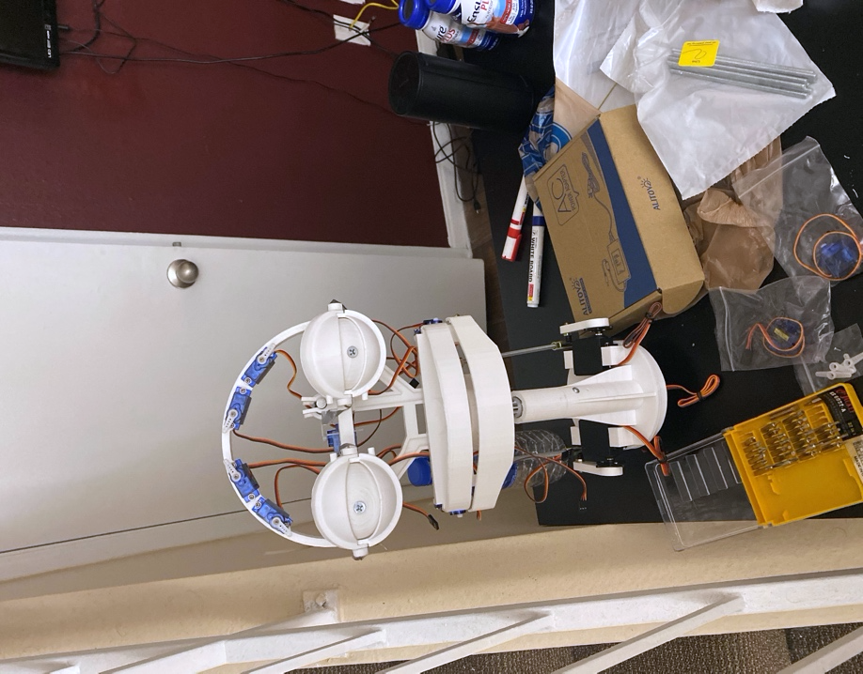

## Lab Session Attendance Log (11/2/2019)

|  |  |
| --- | --- |
| Team Member Name | Time of Stay |
| Sandeep Nadella | 10:00AM to 4:00PM (6 hours) |
| Srivan Reddy | 10:00AM to 4:00PM (6 hours) |
| Sumanth Paranjape | 10:00AM to 4:00PM (6 hours) |
| Shashidhar Reddy | 10:00AM to 4:00PM (6 hours) |
| Arvind Ramesh | 10:00AM to 4:00PM (6 hours) |
| Nabeel | 10:00AM to 2:00PM (4 hours) |

# Lab Session 2

1. Most of the parts of the robots were assembled in the previous session. In this session we focused on enhancing the built robot.
2. We started with assembling and grouping the solid copper wires for electrical connections.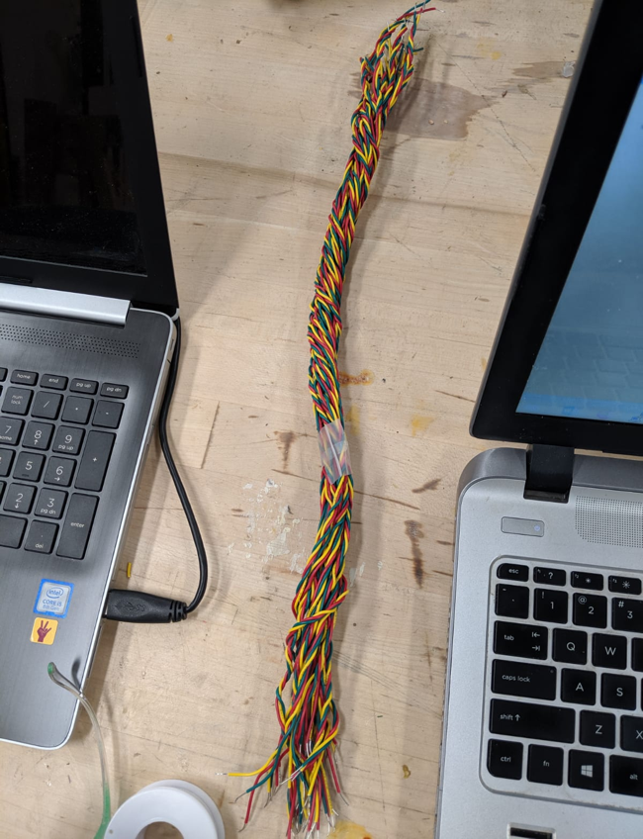
3. We cut the black pipes for robot eyebrows and affixed these to the servo gears.
4. Similarly, we cut the red rubber tube to the desired lip length and affixed these to the servo gears.
5. We were able to get the servo control rods assembled.
6. The eyelid control servo wasn't moving freely in the z-direction, hence, we had to file the supporting H-bridge. Finally, with a little screw fix adjustments we were able to get it move freely.
7. We got the male headers soldered to the PSoC board.
8. We tested the power supply with the Multimeter in lab and checked if it works.
9. We were able to dump the code for eye ball control onto the PSoC. Connection to servos and testing is pending.

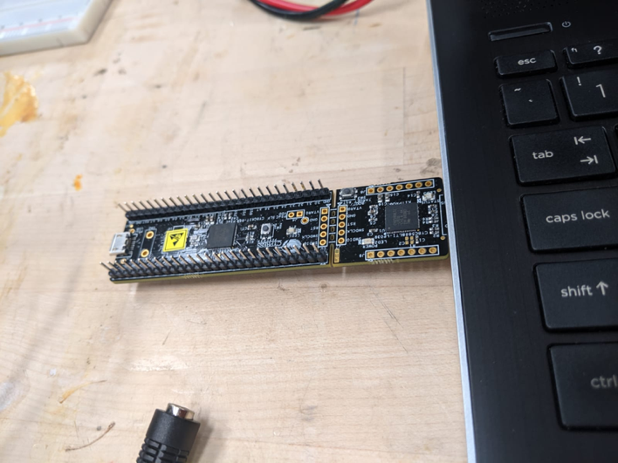

1. The final finished robot looked like this

## Lab Session Attendance Log (11/9/2019)

|  |  |
| --- | --- |
| Team Member Name | Time of Stay |
| Sandeep Nadella | 10:00AM to 4:00PM (6 hours) |
| Srivan Reddy | 10:00AM to 4:00PM (6 hours) |
| Sumanth Paranjape | 10:00AM to 4:00PM (6 hours) |
| Shashidhar Reddy | 10:00AM to 4:00PM (6 hours) |
| Arvind Ramesh | 10:00AM to 4:00PM (6 hours) |
| Nabeel | 10:00AM to 2:00PM (4 hours) |
| Harshita | 10:00AM to 2:00PM (4 hours) |
| Akhilesh | 10:00AM to 4:00PM (6 hours) |
| Manikanta | 10:00AM to 4:00PM (6 hours) |

# Lab Session 3

1. Worked on PSoC Robot Controller coding.
2. The sample code used for controlling the eyeball wasn't smooth so had done a few tweaks like changing the clock frequency to 1MHz and the period to 19ms.
3. The Base, Eyebrows, Neck, Base, Lower Jaw control servo motors are connected to the PSoC and the functions for controlling the movements have been written.

**Eyebrows position for sad expression**

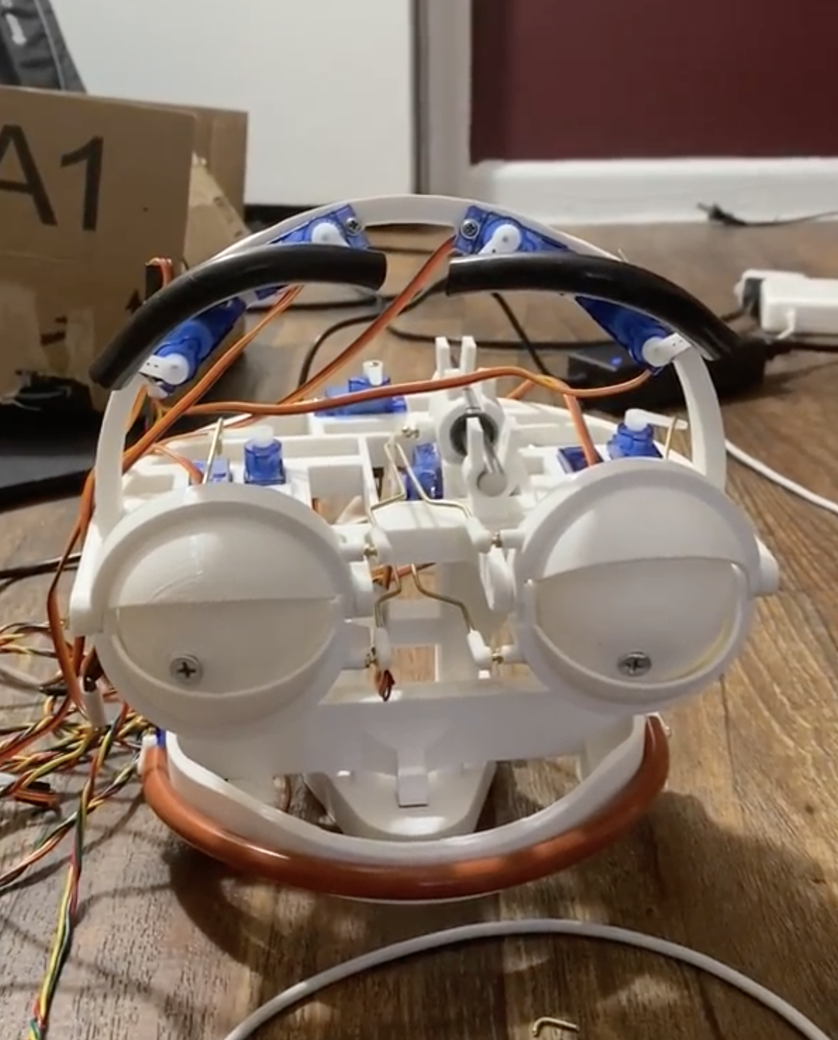

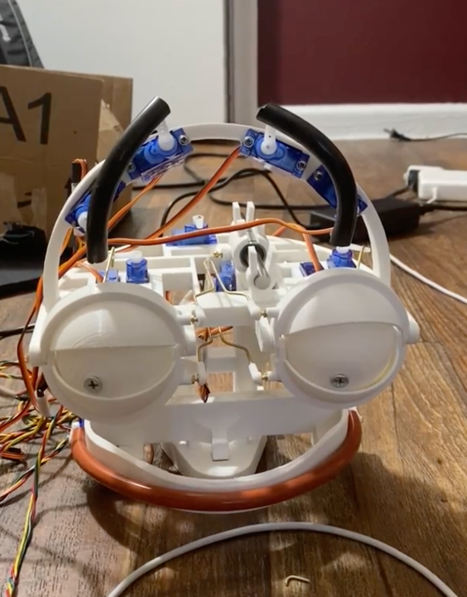**Raised Eyebrows**

**Lower Jaw Open**

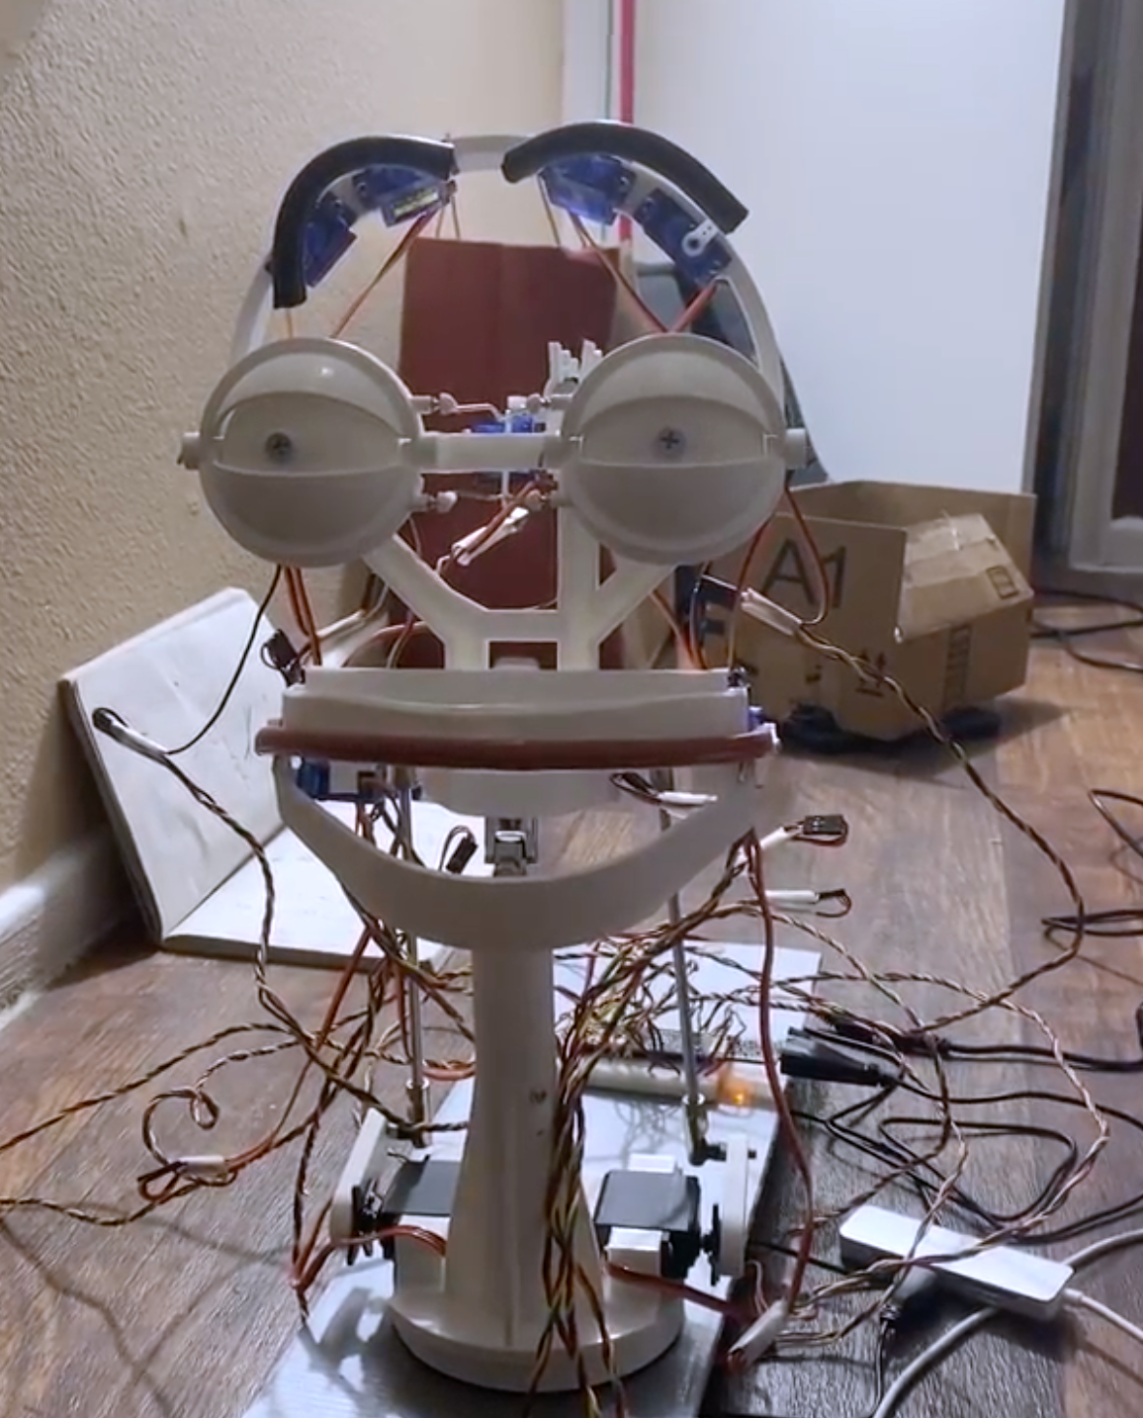

**Closed Lower Jaw**

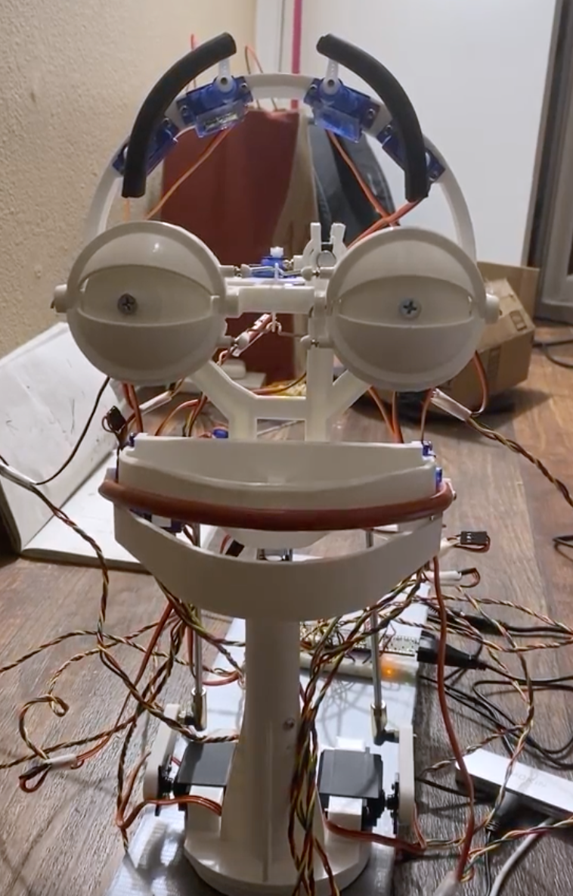



## Lab Session Attendance Log (11/16/2019)

|  |  |
| --- | --- |
| Team Member Name | Time of Stay |
| Sandeep Nadella | 10:00AM to 2:00PM (4 hours) |
| Sumanth Paranjape | 10:00AM to 2:00PM (4 hours) |
| Shashidhar Reddy | 10:00AM to 2:00PM (4 hours) |
| Arvind Ramesh | 10:00AM to 2:00PM (4 hours) |
| Prasoon | 10:00AM to 2:00PM (4 hours) |
| Manikanta | 10:00AM to 2:00PM (4 hours) |
| Surya | 10:00AM to 2:00PM (4 hours) |
| Sajith | 10:00AM to 2:00PM (4 hours) |

# Step by Step Build Procedure

|  |  |
| --- | --- |
| A desk with a computer monitor  Description automatically generated  The 3D models are dumped into the 3D printer and printed with the recommended settings | The set of all 3D printed parts |
| The H-bridge, Upper jaw, Neck Mount parts are assembled as shown in picture | A picture containing indoor, floor, wall  Description automatically generated  The eyeballs and eyelids are assembled as shown in the picture |

|  |  |
| --- | --- |
| The eyebrow support is mounted as shown in the picture and the servos are mounted | The servos for controlling the bottom eyelids and for horizontal eyeball motion are fixed to the head base support |
| The top view showing the servos assembled to control the vertical eyeball motion and opening, closing of the eyelids | The view showing the lips motion control servos |
| The base mount is connected to the large 1501MG servo for head rotation | Two large 1501MG servos are connected to the base robot neck using threaded rods for controlling the motion of the head |

|  |  |
| --- | --- |
| A close up of a cluttered table  Description automatically generated  Cut brass rods are used for connecting the servo arms to the eyelids and eyeballs (bottom view) | A picture containing indoor, floor  Description automatically generated  Cut brass rods are used for connecting the servo arms to the eyelids and eyeballs  (top view) |
| A picture containing person, indoor, man  Description automatically generated  The eyebrow pipes are connected to the servo arms using cutting threaded screws | A picture containing floor, indoor, ground  Description automatically generated  The frontal view of the eyebrows |

|  |  |
| --- | --- |
| The Universal Joint is attached to the neck mount which allows for the head motion in all directions. The upper lip is attached to the upper lip servos. | The complete view of the robot assembled till this step |
| The head portion is assembled to the base neck support using the universal joint and upper robot neck | A picture containing building, wall, outdoor  Description automatically generated  A set of about 16 - 3 single stranded wires are used for electrical connections |

|  |  |
| --- | --- |
| The brown ground wire from servos is connected to the green wire, the red live wire is connected to the red wire and the orange signal wire is connected to the yellow wire. The PWM config needed is shown above which is picked from the datasheet. | The bottom lip can be glued as shown in the picture. |
| A close up of a bicycle  Description automatically generated  The pictures shows the robot after the wires are connected to the servos. The wires can be grouped with some plaster. | A picture containing person, indoor, ground, table  Description automatically generated  The picture showing the complete view of the robot. |

|  |  |
| --- | --- |
| The wires from the servos are connected to the PSoC control board which is used for programming their motion. | A picture containing indoor, wall, floor, table  Description automatically generated  Several facial expressions can be programmed like the raised eyebrow expression shown in the above image |